Radial Arrangement

Definition
# Source: AI Source: Provided by: [Data Path: Persons Table -> ID Column: 1, Name_En Column: Motasem Essam] -> From: [ChatGPT] on [7/25/2026]
A Radial Arrangement is a type of composite solid arrangement in which two or more solid components are positioned around a common central point, central axis, or central solid.
The components extend outward from the center or are distributed around it according to a circular, angular, or rotational pattern.
A radial arrangement may contain identical or different solid components, and its overall structure may exhibit rotational symmetry or an irregular distribution.

Simple Definition
# Source: AI Source: Provided by: [Data Path: Persons Table -> ID Column: 1, Name_En Column: Motasem Essam] -> From: [ChatGPT] on [7/25/2026]
A radial arrangement is a composite solid in which multiple components are organized around a common center, extending outward like the spokes of a wheel.

Geometric Representation
# Source: AI Source: Provided by: [Data Path: Persons Table -> ID Column: 1, Name_En Column: Motasem Essam] -> From: [ChatGPT] on [7/25/2026]
A radial arrangement can be represented using repeated cubes, rectangular prisms, cylinders, cones, or other solids positioned around a central component.
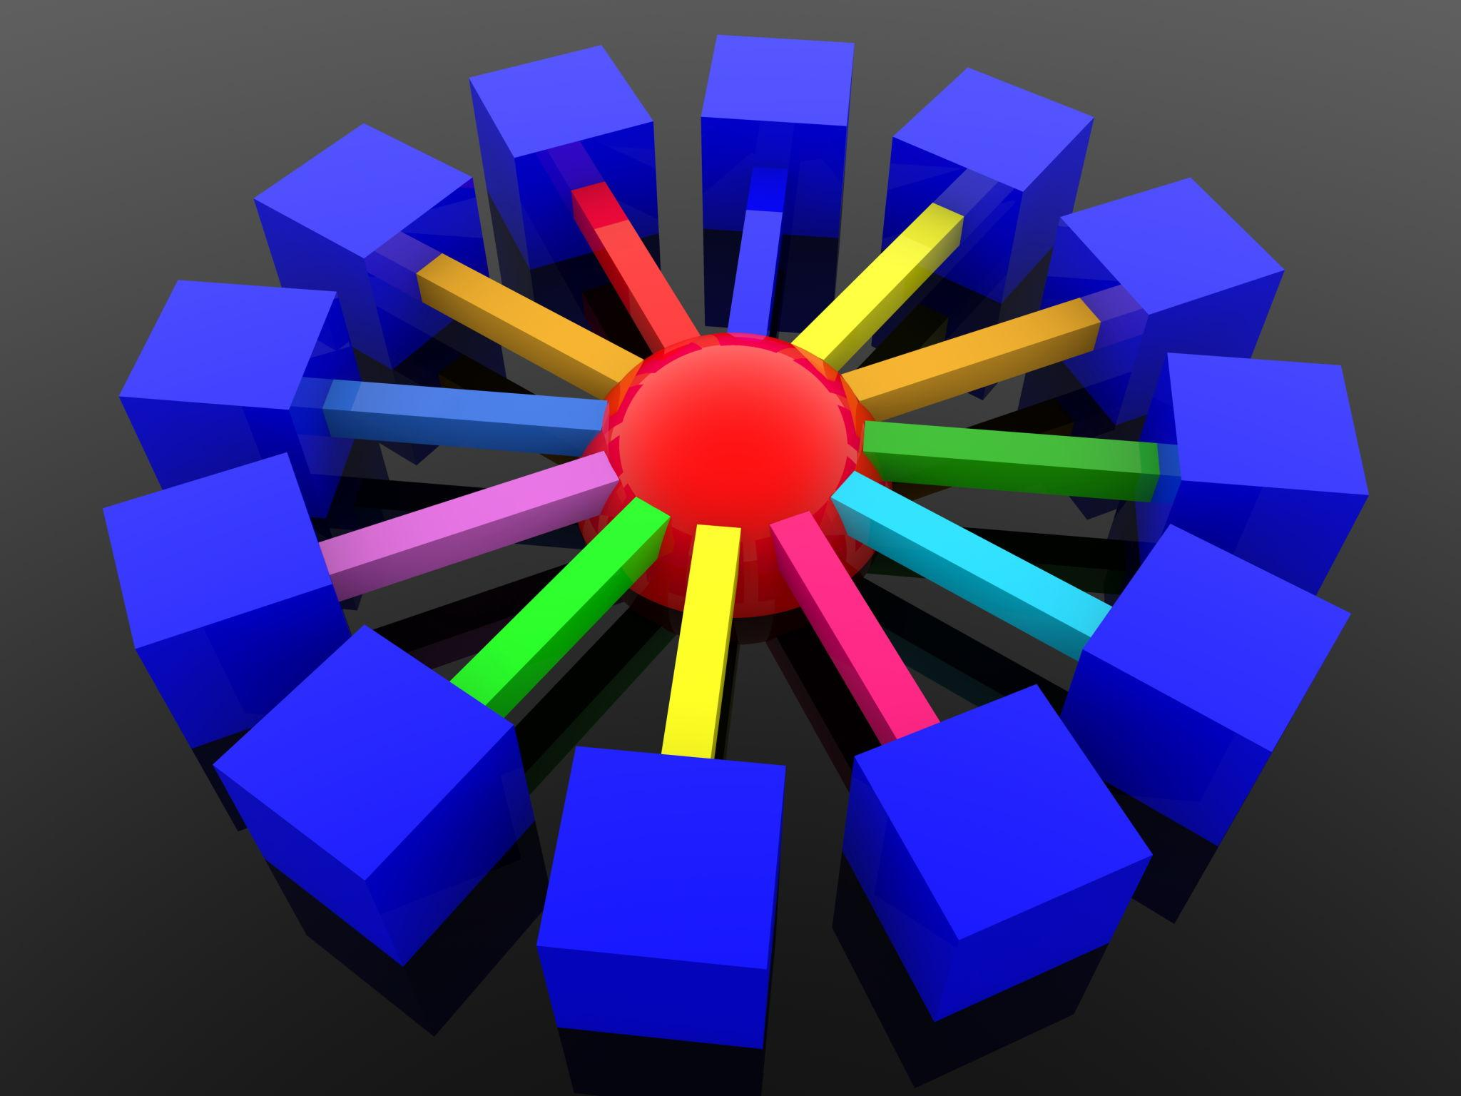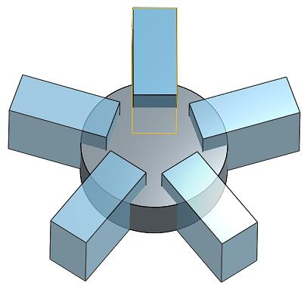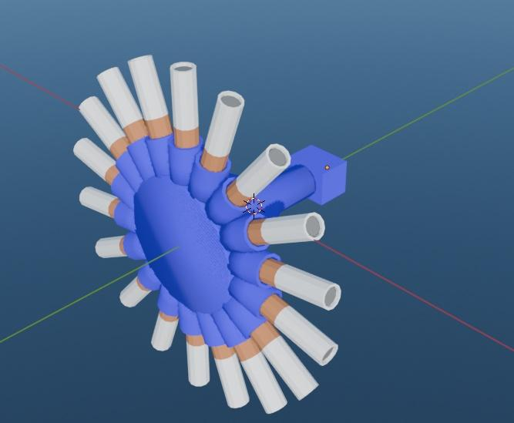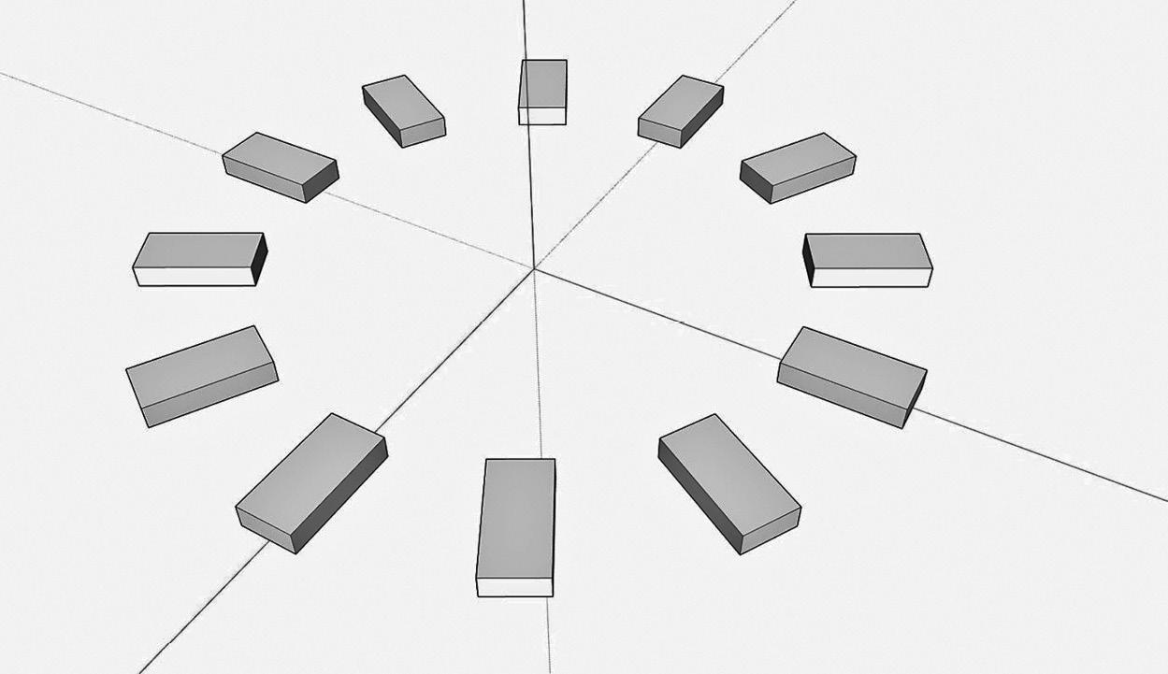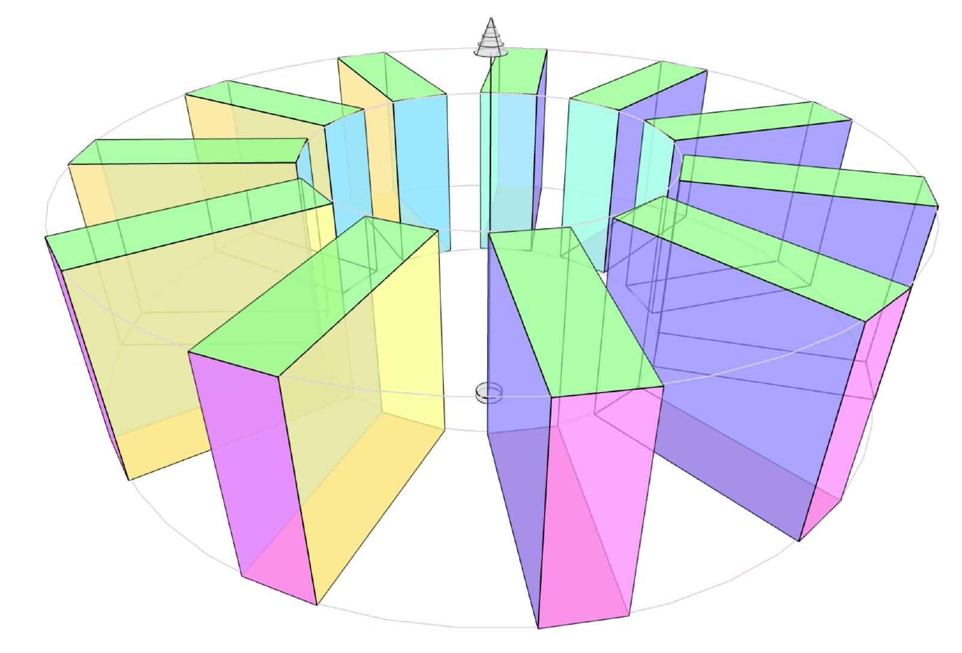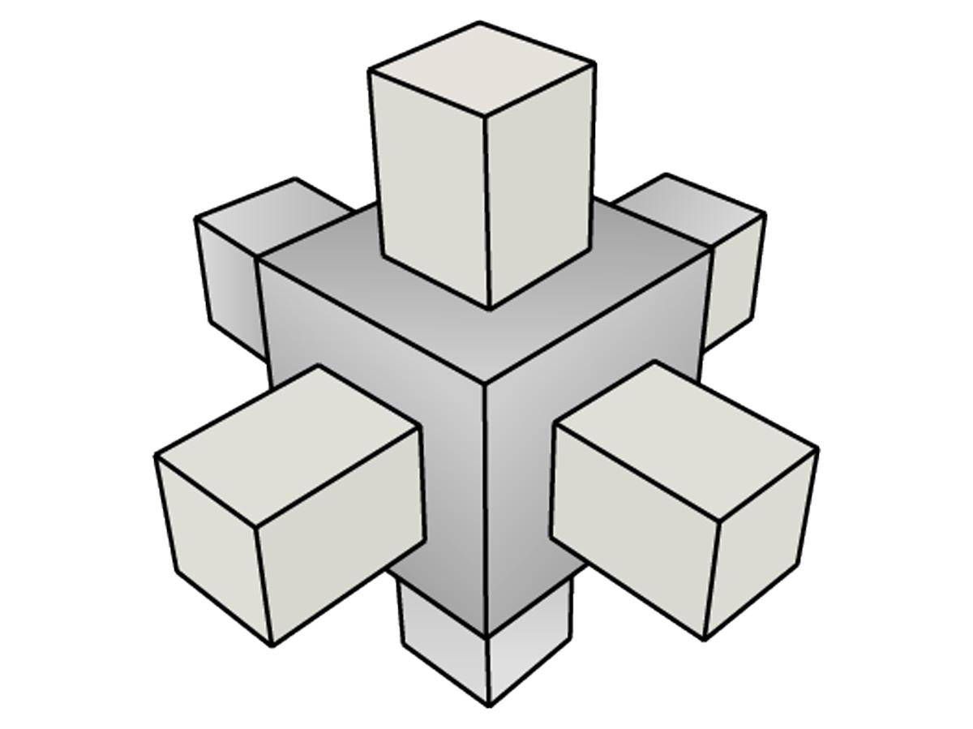
Main geometric elements:
- Central Point: The common reference point around which components are distributed.
- Central Axis: An axis around which components may be arranged rotationally.
- Central Component: A solid positioned at the center, if one is present.
- Radial Components: The solids extending outward from the center.
- Radial Direction: The direction from the center toward each component.
- Angular Separation: The angle between the radial directions of neighboring components.

Main Classification
# Source: AI Source: Provided by: [Data Path: Persons Table -> ID Column: 1, Name_En Column: Motasem Essam] -> From: [ChatGPT] on [7/25/2026]
Radial arrangements can be classified according to the central structure, component distribution, angular pattern, and geometric shape.

Classification by Central Structure
# Source: AI Source: Provided by: [Data Path: Persons Table -> ID Column: 1, Name_En Column: Motasem Essam] -> From: [ChatGPT] on [7/25/2026]
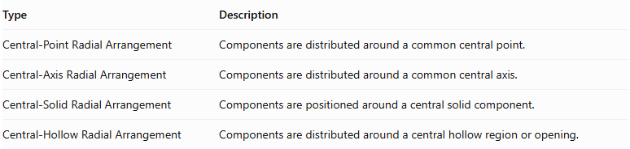
Type | Description
Central-Point Radial Arrangement | Components are distributed around a common central point.
Central-Axis Radial Arrangement | Components are distributed around a common central axis.
Central-Solid Radial Arrangement | Components are positioned around a central solid component.
Central-Hollow Radial Arrangement | Components are distributed around a central hollow region or opening.
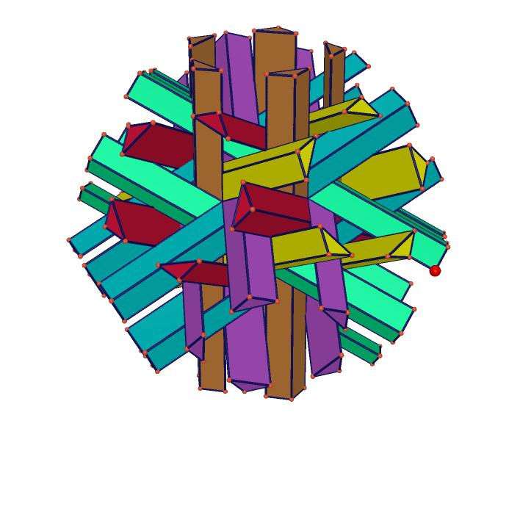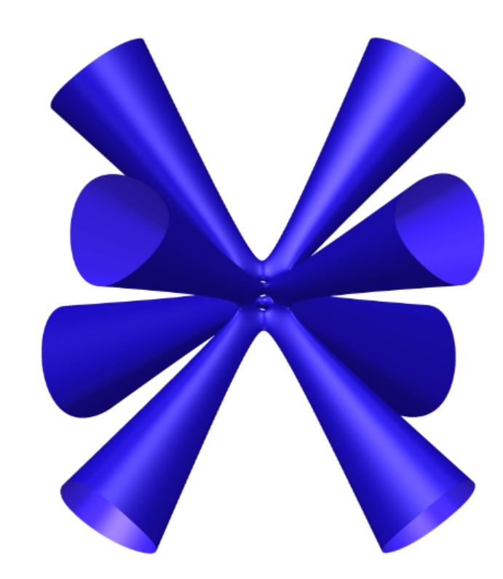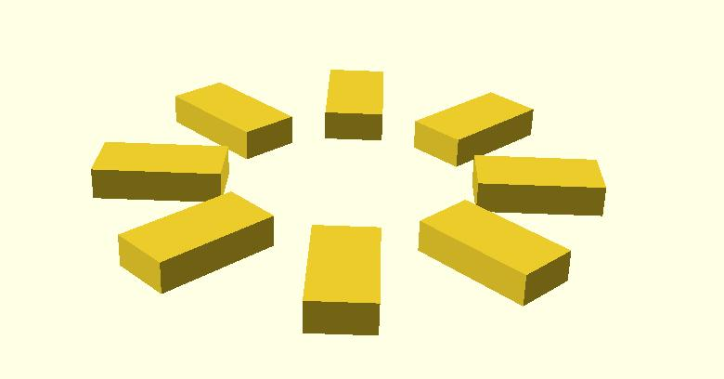

Classification by Angular Distribution
# Source: AI Source: Provided by: [Data Path: Persons Table -> ID Column: 1, Name_En Column: Motasem Essam] -> From: [ChatGPT] on [7/25/2026]
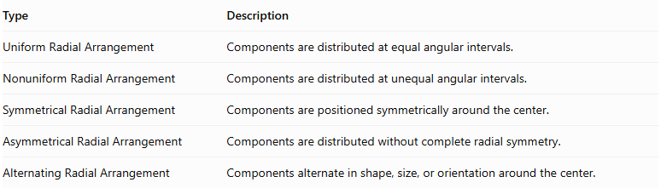
Type | Description
Uniform Radial Arrangement | Components are distributed at equal angular intervals.
Nonuniform Radial Arrangement | Components are distributed at unequal angular intervals.
Symmetrical Radial Arrangement | Components are positioned symmetrically around the center.
Asymmetrical Radial Arrangement | Components are distributed without complete radial symmetry.
Alternating Radial Arrangement | Components alternate in shape, size, or orientation around the center.
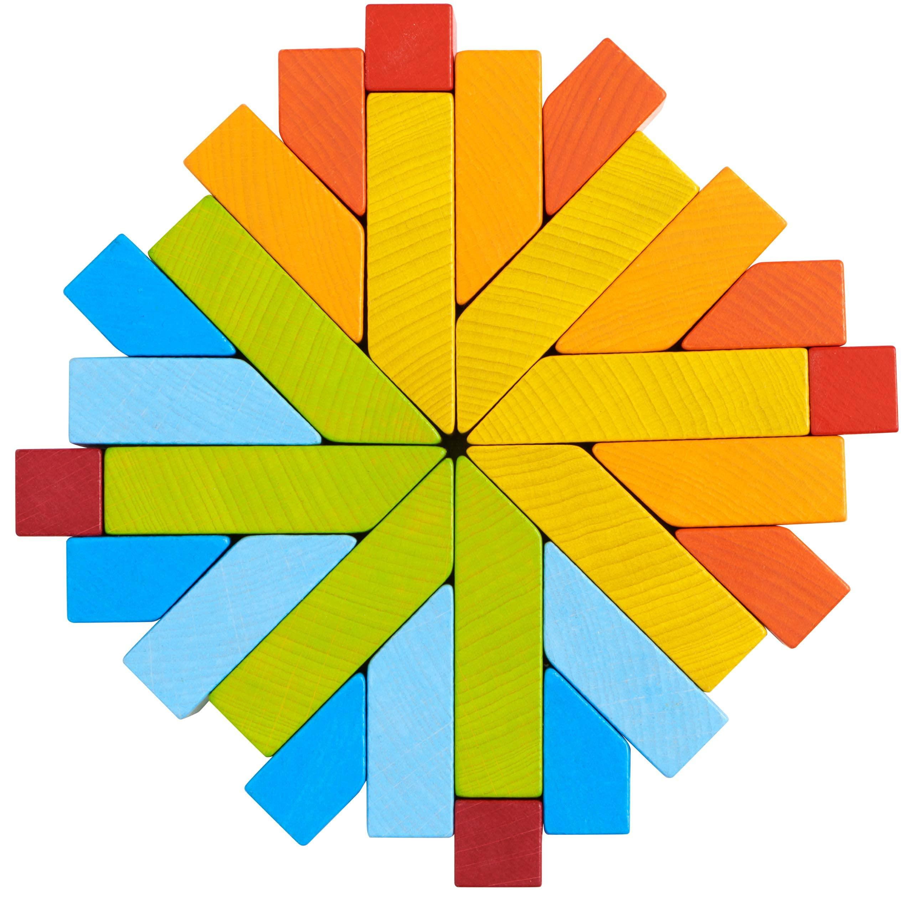

Classification by Radial Pattern
# Source: AI Source: Provided by: [Data Path: Persons Table -> ID Column: 1, Name_En Column: Motasem Essam] -> From: [ChatGPT] on [7/25/2026]
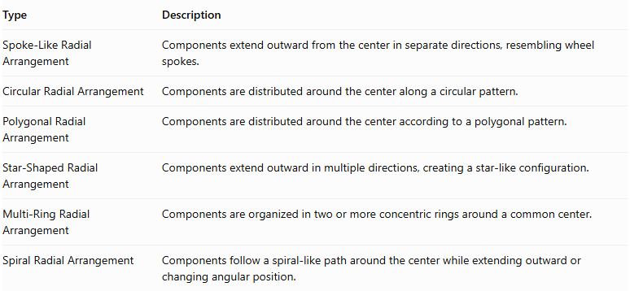
Type | Description
Spoke-Like Radial Arrangement | Components extend outward from the center in separate directions, resembling wheel spokes.
Circular Radial Arrangement | Components are distributed around the center along a circular pattern.
Polygonal Radial Arrangement | Components are distributed around the center according to a polygonal pattern.
Star-Shaped Radial Arrangement | Components extend outward in multiple directions, creating a star-like configuration.
Multi-Ring Radial Arrangement | Components are organized in two or more concentric rings around a common center.
Spiral Radial Arrangement | Components follow a spiral-like path around the center while extending outward or changing angular position.
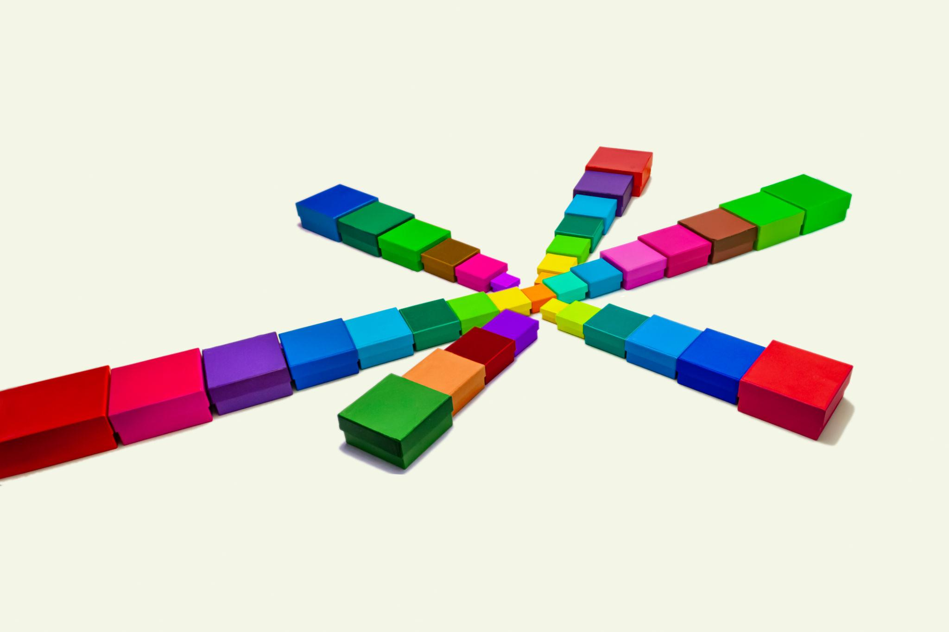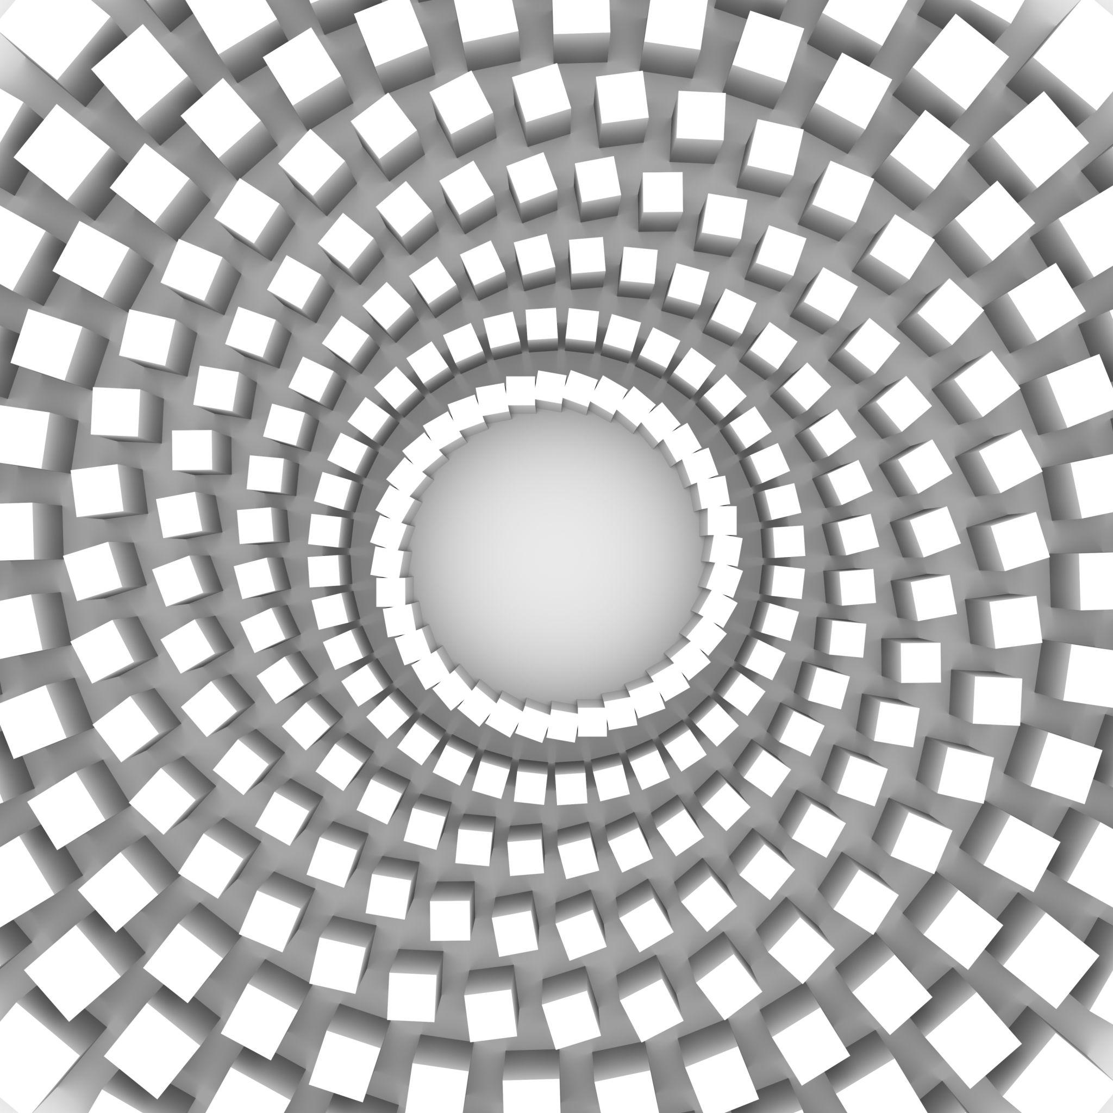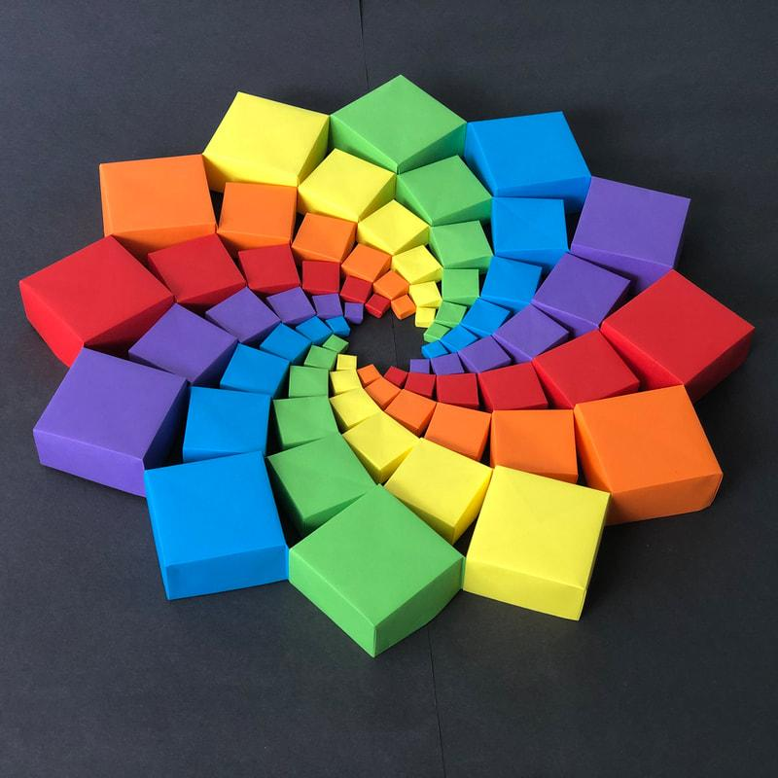

Classification by Component Orientation
# Source: AI Source: Provided by: [Data Path: Persons Table -> ID Column: 1, Name_En Column: Motasem Essam] -> From: [ChatGPT] on [7/25/2026]
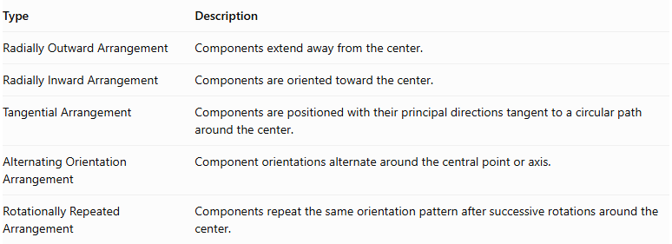
Type | Description
Radially Outward Arrangement | Components extend away from the center.
Radially Inward Arrangement | Components are oriented toward the center.
Tangential Arrangement | Components are positioned with their principal directions tangent to a circular path around the center.
Alternating Orientation Arrangement | Component orientations alternate around the central point or axis.
Rotationally Repeated Arrangement | Components repeat the same orientation pattern after successive rotations around the center.
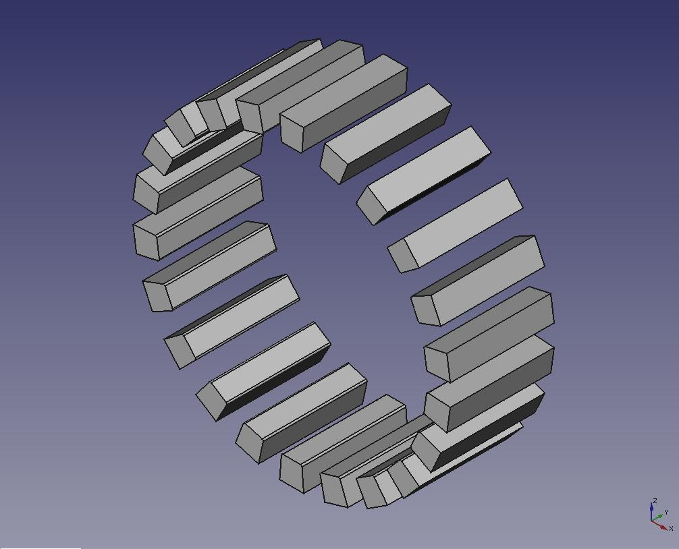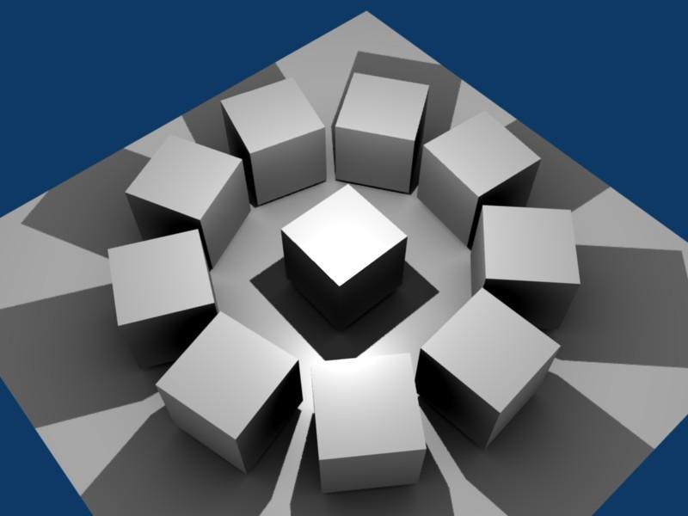

Classification by Component Shape
# Source: AI Source: Provided by: [Data Path: Persons Table -> ID Column: 1, Name_En Column: Motasem Essam] -> From: [ChatGPT] on [7/25/2026]
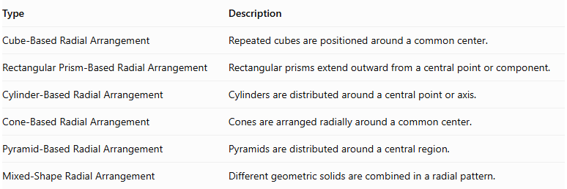
Type | Description
Cube-Based Radial Arrangement | Repeated cubes are positioned around a common center.
Rectangular Prism-Based Radial Arrangement | Rectangular prisms extend outward from a central point or component.
Cylinder-Based Radial Arrangement | Cylinders are distributed around a central point or axis.
Cone-Based Radial Arrangement | Cones are arranged radially around a common center.
Pyramid-Based Radial Arrangement | Pyramids are distributed around a central region.
Mixed-Shape Radial Arrangement | Different geometric solids are combined in a radial pattern.
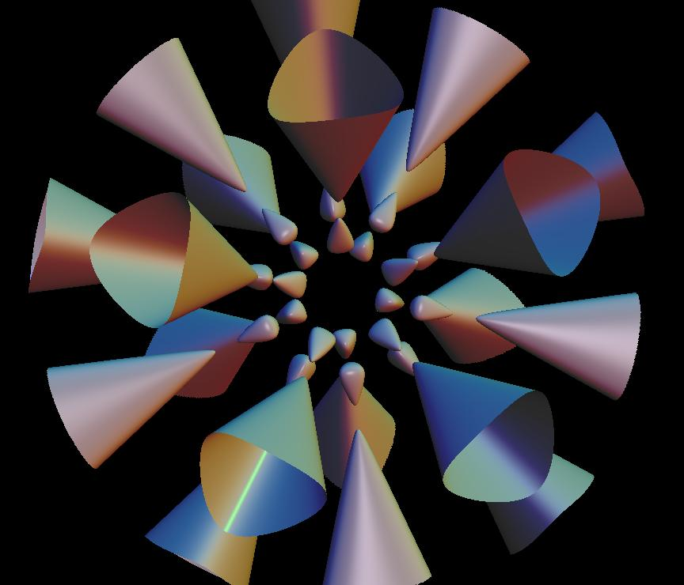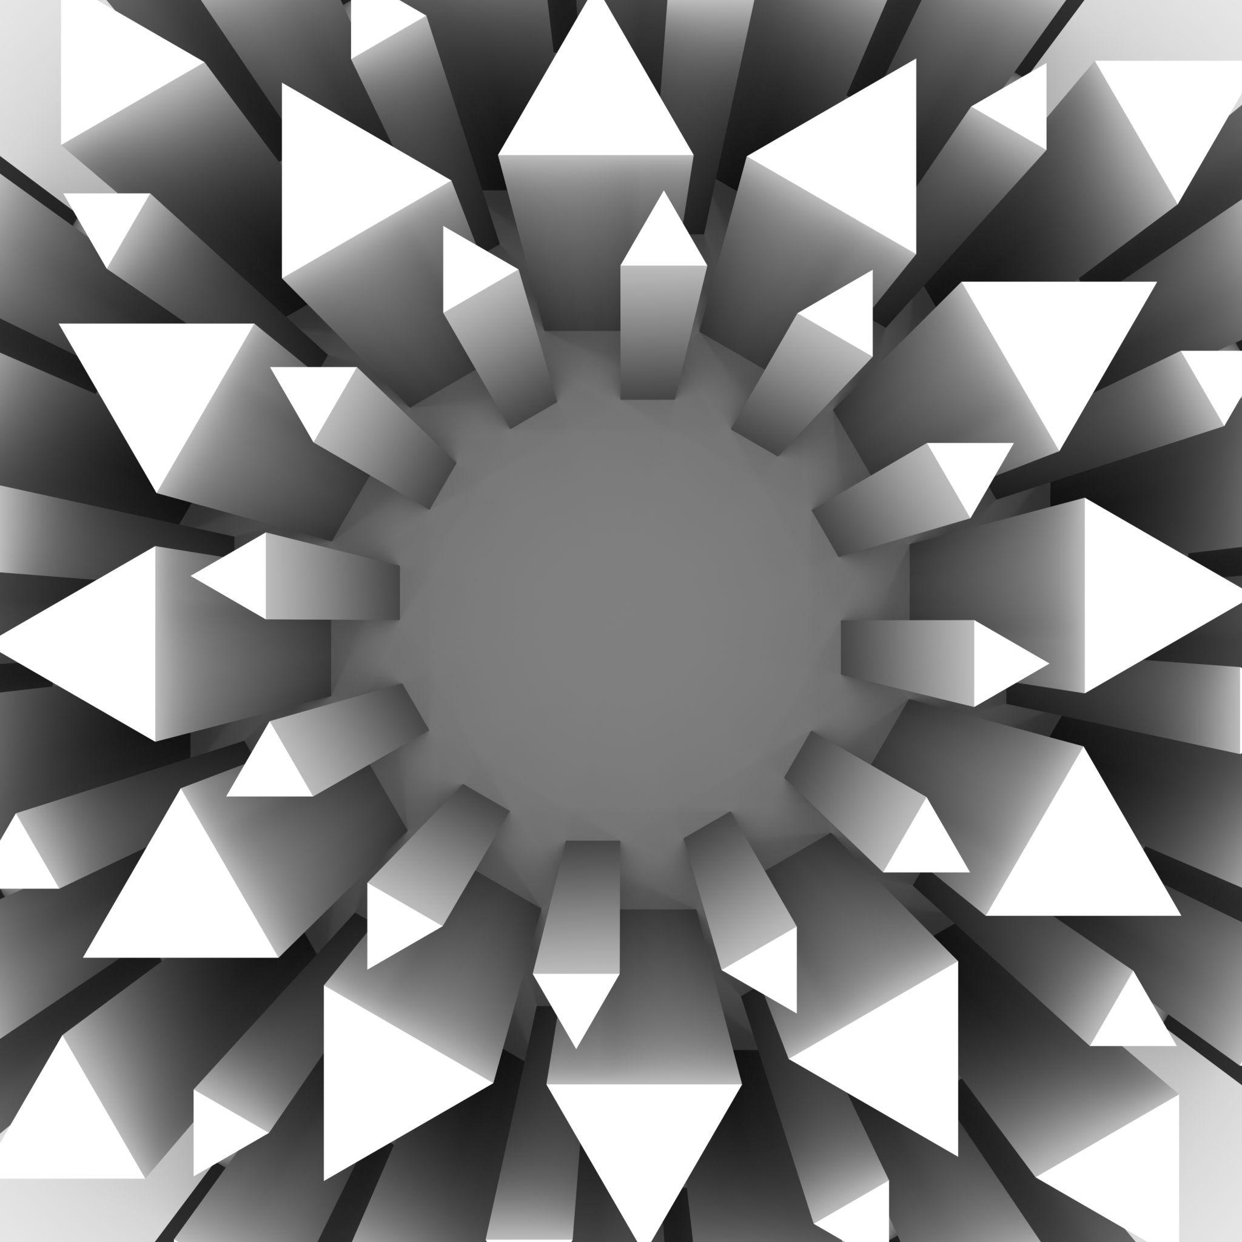

Classification by Component Dimensions
# Source: AI Source: Provided by: [Data Path: Persons Table -> ID Column: 1, Name_En Column: Motasem Essam] -> From: [ChatGPT] on [7/25/2026]
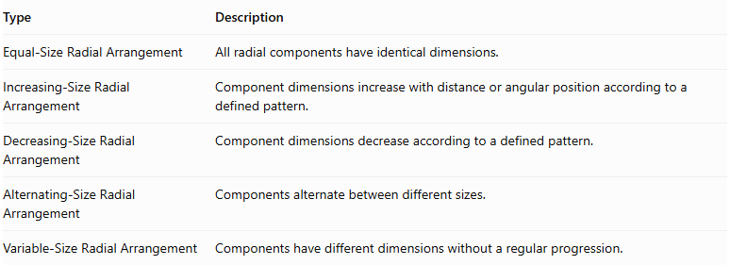
Type | Description
Equal-Size Radial Arrangement | All radial components have identical dimensions.
Increasing-Size Radial Arrangement | Component dimensions increase with distance or angular position according to a defined pattern.
Decreasing-Size Radial Arrangement | Component dimensions decrease according to a defined pattern.
Alternating-Size Radial Arrangement | Components alternate between different sizes.
Variable-Size Radial Arrangement | Components have different dimensions without a regular progression.

Mathematical Properties and Formulas

Angular Separation
# Source: AI Source: Provided by: [Data Path: Persons Table -> ID Column: 1, Name_En Column: Motasem Essam] -> From: [ChatGPT] on [7/25/2026]
For $N$ equally spaced components distributed around a full circle:
$$\boxed{θ=\frac{{360}^{∘}}{N}}$$
Where:
- $θ$ = Angular separation between successive components.
- $N$ = Number of radial components.
Examples:
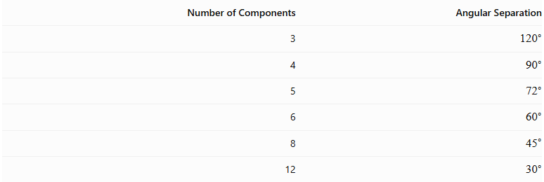
Number of Components | Angular Separation
3 | $${120}^{∘}$$
4 | $${90}^{∘}$$
5 | $${72}^{∘}$$
6 | $${60}^{∘}$$
8 | $${45}^{∘}$$
12 | $${30}^{∘}$$

Total Number of Components
# Source: AI Source: Provided by: [Data Path: Persons Table -> ID Column: 1, Name_En Column: Motasem Essam] -> From: [ChatGPT] on [7/25/2026]
If there is one central component and $N$ radial components:
$$\boxed{N_{total}=N+1}$$
For multiple radial rings:
$$\boxed{N_{total}=N_{c}+\sum_{i=1}^{R}{N_{i}}}$$
Where:
- $N_{c}$ = Number of central components.
- $R$ = Number of radial rings.
- $N_{i}$ = Number of components in ring $i$.

Total Volume
# Source: AI Source: Provided by: [Data Path: Persons Table -> ID Column: 1, Name_En Column: Motasem Essam] -> From: [ChatGPT] on [7/25/2026]
For non-overlapping components:
$$\boxed{V_{total}=\sum_{i=1}^{N}{V_{i}}}$$
If all radial components are identical and there is one central component:
$$\boxed{V_{total}=V_{c}+{NV}_{r}}$$
Where:
- $V_{c}$ = Volume of the central component.
- $V_{r}$ = Volume of one radial component.

Radial Position
# Source: AI Source: Provided by: [Data Path: Persons Table -> ID Column: 1, Name_En Column: Motasem Essam] -> From: [ChatGPT] on [7/25/2026]
For a component positioned at a distance $r$ from the center in a two-dimensional radial pattern:
$$x=rcosθ$$
$$y=rsinθ$$
For equally spaced components:
$$θ_{i}=θ_{0}+\frac{{360}^{∘}i}{N}$$
Where:
- $r$ = Radial distance from the center.
- $θ_{0}$ = Initial angular position.
- $i$ = Component index, beginning at zero.
These equations describe the positions of component reference points, such as their centers. They do not by themselves determine whether the complete solid components touch or overlap.

External Surface Area
# Source: AI Source: Provided by: [Data Path: Persons Table -> ID Column: 1, Name_En Column: Motasem Essam] -> From: [ChatGPT] on [7/25/2026]
The external surface area is the sum of all exposed component surfaces after assembly.
For components joined through complete matching planar interfaces:
$${SA}_{external}=\sum{{SA}_{i}}-2\sum{A_{interface}}$$
For partial contact or curved intersections, only the actual hidden surface regions should be excluded. The geometry of each contact region must be considered separately.

Worked Examples

Example 1: Four Cubes Arranged Radially Around a Central Cube
# Source: AI Source: Provided by: [Data Path: Persons Table -> ID Column: 1, Name_En Column: Motasem Essam] -> From: [ChatGPT] on [7/25/2026]
Problem:
A composite solid consists of one central cube surrounded by four identical cubes. Each radial cube is attached to one side of the central cube. All five cubes have a side length of 4 cm.
Calculate:
- The total number of cubes.
- The total volume.
- The angular separation between the radial components.
- The external surface area.

Step 1: Calculate the total number of cubes.
$$N_{total}=1+4=5$$
Step 2: Calculate the volume of one cube.
$$V_{cube}=s^{3}$$
$$V_{cube}=4^{3}=64{ cm}^{3}$$
Step 3: Calculate the total volume.
$$V_{total}=5×64$$
$$\boxed{V_{total}=320{ cm}^{3}}$$
Step 4: Calculate the angular separation.
$$θ=\frac{{360}^{∘}}{4}$$
$$\boxed{θ={90}^{∘}}$$
Step 5: Calculate the external surface area.
The total surface area before joining is:
$${SA}_{initial}=5(6s^{2})$$
$$=5(6×16)=480{ cm}^{2}$$
There are four complete shared square interfaces, each with area:
$$A_{interface}=4^{2}=16{ cm}^{2}$$
Therefore:
$${SA}_{external}=480-2(4×16)$$
$$\boxed{{SA}_{external}=352{ cm}^{2}}$$

Example 2: Six Cylinders Arranged Around a Central Cylinder
# Source: AI Source: Provided by: [Data Path: Persons Table -> ID Column: 1, Name_En Column: Motasem Essam] -> From: [ChatGPT] on [7/25/2026]
Problem:
A composite solid consists of one central cylinder surrounded by six identical cylinders. All cylinders have a radius of 2 cm and a height of 5 cm.
Calculate:
- The total number of cylinders.
- The total volume.
- The angular separation between radial components.
Assume the six outer cylinders are arranged at equal angular intervals around the central cylinder, and their positions are selected so that they do not overlap.
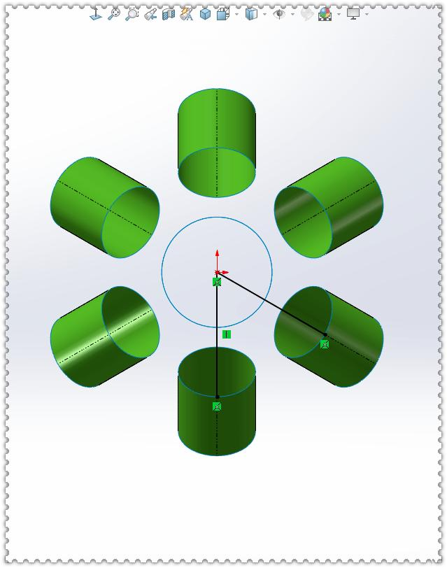
Step 1: Calculate the total number of cylinders.
$$N_{total}=1+6=7$$
Step 2: Calculate the volume of one cylinder.
$$V=πr^{2}h$$
$$V=π(2)^{2}(5)$$
$$V=20π{ cm}^{3}$$
Step 3: Calculate the total volume.
$$V_{total}=7×20π$$
$$\boxed{V_{total}=140π≈439.82{ cm}^{3}}$$
Step 4: Calculate the angular separation.
$$θ=\frac{{360}^{∘}}{6}$$
$$\boxed{θ={60}^{∘}}$$
Note: This example calculates the combined volume and angular distribution. The external surface area would require additional information about the exact positions and contact regions of the cylinders.

Important Characteristics
# Source: AI Source: Provided by: [Data Path: Persons Table -> ID Column: 1, Name_En Column: Motasem Essam] -> From: [ChatGPT] on [7/25/2026]
- Components are distributed around a common central reference.
- The arrangement may be based on a central point, axis, or solid.
- Components may extend outward, face inward, or follow tangential orientations.
- Angular separation may be uniform or nonuniform.
- The arrangement may exhibit rotational or reflectional symmetry.
- Components may have identical or different dimensions.
- Radial patterns may be circular, polygonal, spoke-like, star-shaped, or spiral-like.
- Multiple concentric rings may be used to create more complex structures.
- The total volume is the sum of component volumes when there is no overlap.
- External surface area depends on the actual contact and intersection regions.

Comparison with Other Component Arrangements
# Source: AI Source: Provided by: [Data Path: Persons Table -> ID Column: 1, Name_En Column: Motasem Essam] -> From: [ChatGPT] on [7/25/2026]
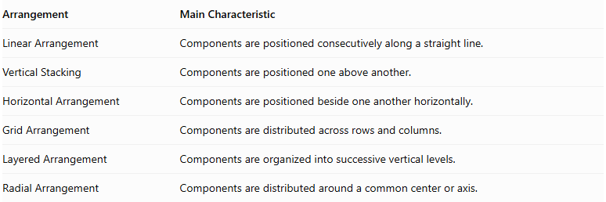
Arrangement | Main Characteristic
Linear Arrangement | Components are positioned consecutively along a straight line.
Vertical Stacking | Components are positioned one above another.
Horizontal Arrangement | Components are positioned beside one another horizontally.
Grid Arrangement | Components are distributed across rows and columns.
Layered Arrangement | Components are organized into successive vertical levels.
Radial Arrangement | Components are distributed around a common center or axis.
Radial vs. Grid Arrangement: A grid arrangement organizes components into rows and columns, while a radial arrangement organizes them around a central reference.
Radial vs. Layered Arrangement: A layered arrangement organizes components by vertical levels, while a radial arrangement organizes them by angular or radial position. Both classifications can occur in the same composite solid.

Real-World Applications
# Source: AI Source: Provided by: [Data Path: Persons Table -> ID Column: 1, Name_En Column: Motasem Essam] -> From: [ChatGPT] on [7/25/2026]
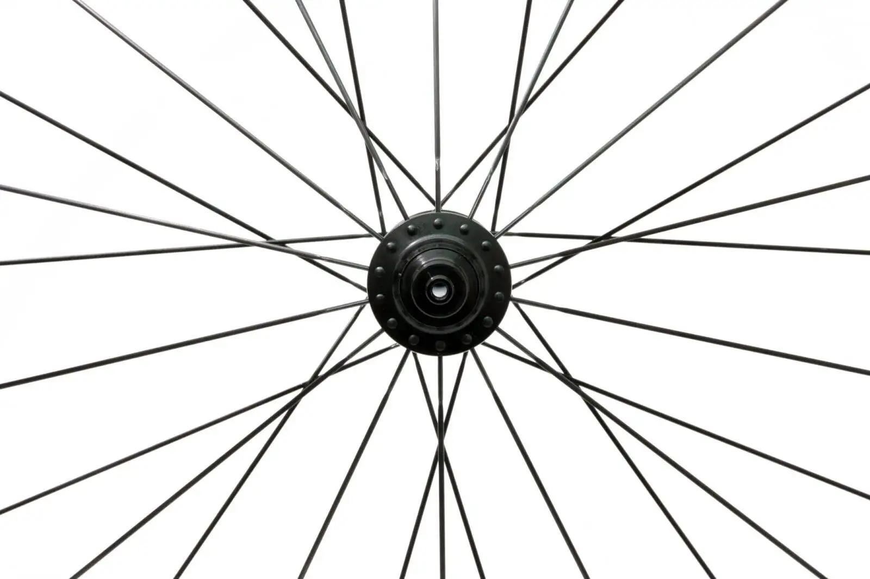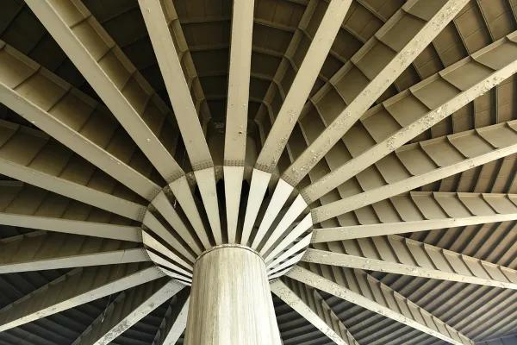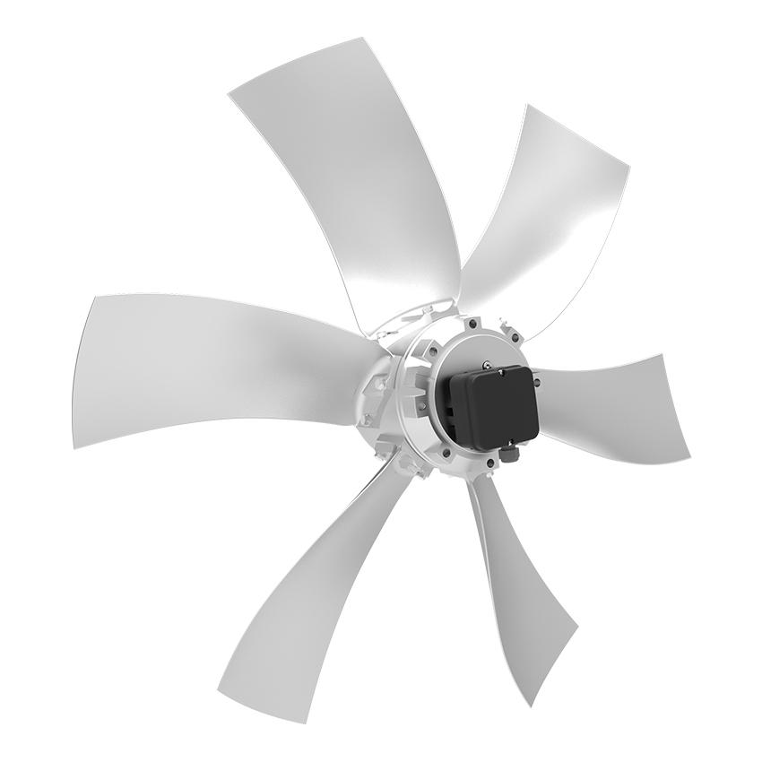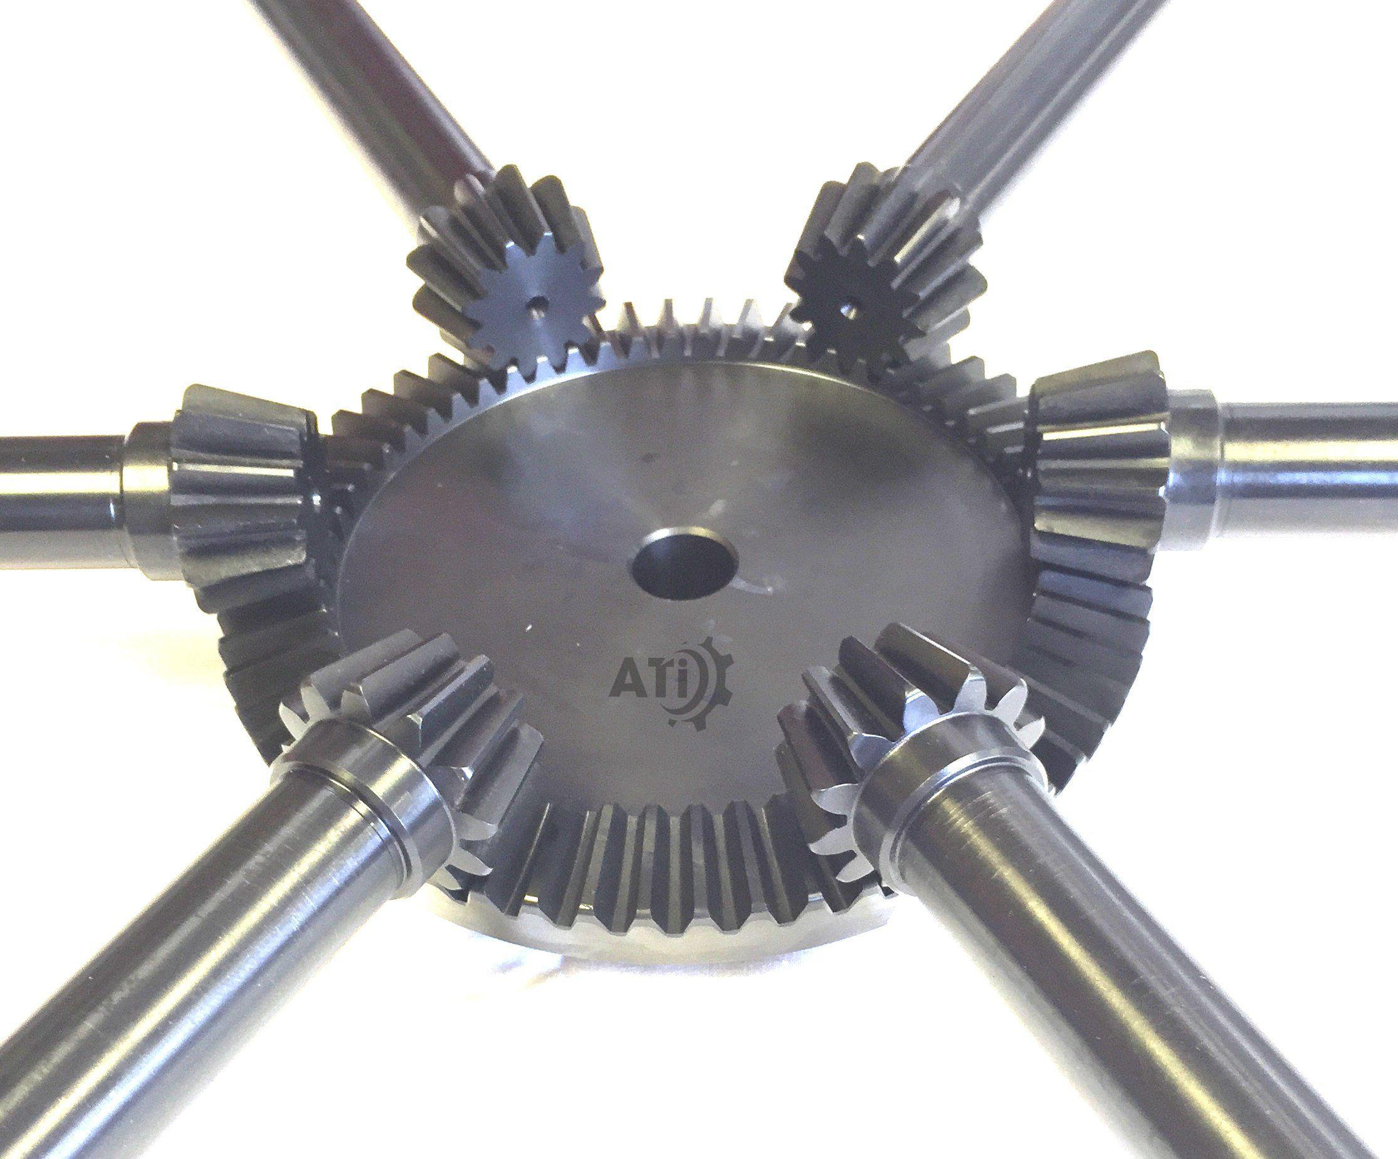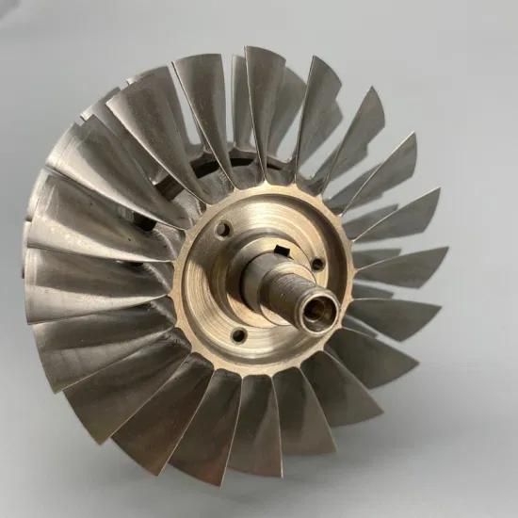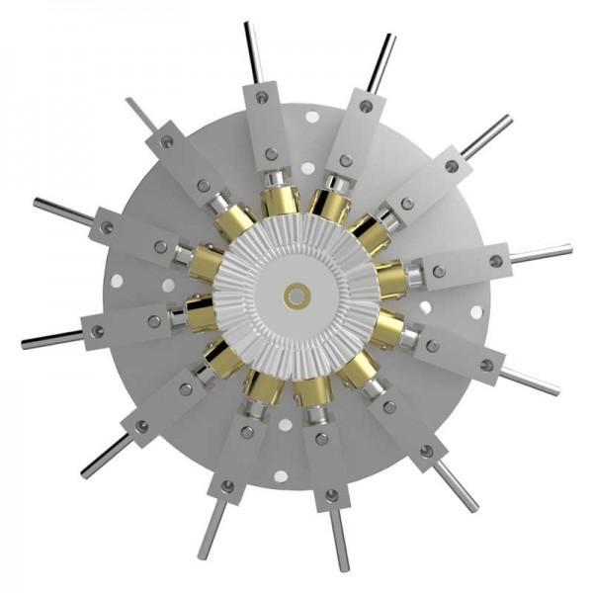
- Mechanical Engineering: Gears, turbine blades, and rotating mechanical assemblies.
- Architecture: Structures organized around central columns or circular spaces.
- Transportation: Wheel spokes and hub assemblies.
- Manufacturing: Components arranged around a central shaft or supporting structure.
- Industrial Design: Radial arrangements used in fans, impellers, and rotating equipment.
- Mathematical Modeling: Studying rotational symmetry, angular distribution, and three-dimensional spatial relationships.

Key Points
# Source: AI Source: Provided by: [Data Path: Persons Table -> ID Column: 1, Name_En Column: Motasem Essam] -> From: [ChatGPT] on [7/25/2026]
- A radial arrangement organizes components around a common center or axis.
- Components may extend outward, point inward, or follow tangential directions.
- Equal angular spacing is calculated using ${360}^{∘}/N$.
- Radial patterns may be circular, polygonal, spoke-like, star-shaped, or spiral-like.
- Components may be identical or different in shape and dimensions.
- Multiple radial rings can form more complex arrangements.
- Radial arrangements may also be combined with layered or grid arrangements.
- Volume and surface area calculations depend on component overlap and contact.

Conclusion
# Source: AI Source: Provided by: [Data Path: Persons Table -> ID Column: 1, Name_En Column: Motasem Essam] -> From: [ChatGPT] on [7/25/2026]
A Radial Arrangement is a classification of composite solids based on positioning components around a common central point, axis, or solid. Its defining characteristic is the distribution of components according to radial directions or angular positions.
It is particularly useful for describing structures with rotational patterns, including spoke-like configurations, circular arrangements, concentric rings, and star-shaped structures.

